Simulation and Analysis

A Simulation with a particular set of parameters is run for 100 times and the average is taken to make the plots as mentioned in previous chapter. A grid lattice of 25x25 is considered making it a population of 625. To initialize with , 4 cells are infected in the top left corner. A corner is chosen to bring out the maximum effect of spread through local. It was observed that the local spread from a corner is slower than considering from the center. But it did not make any significant changes in global transmission. So 4 cells was considered in the 10x10 lattice in the corner when initializing. During the spread of the virus through local spread at a time step It is considered that an infected cell will transmit the virus to only one person. While the spread through global transmission is much more drastic. A susceptible is likely to get infected from more number of infected cell to denote that during community spread in real world. A real life infected person could visit many people in a day. This will be case when he either chose to keep his infection anonymous or he is an asymptotic carrier of the virus. One could say that the simulation could be scaled to make a comparison to desired locality or state. To make the analysis various configuration of the disease spread is made. While making the plots Inter Quartile Range for the infected is plotted along with the averaged simulated infected. IQR will give u good idea about the presence of the simulation as it will avoid the extreme ends. The length of the IQR will give us an idea how volatile the simulations were. And also if the length is small it show that the all the simulation were consistent and has followed the same trend with out much deviation.

Following are the features that are considered as the configuration of the simulation.

Beta – Rate of transmission

Gamma – Rate of Recovery

TR – Transmission Ratio

Number of Vaccination a Day

Mu – efficacy of the vaccination

Fully Global and Fully local transmission

We simulate the population with a single mode of transmission of the virus. That is the population will go total global transmission which can be considered as group gathering in the community in respect to the real life. But it is highly unlikely to happen because as the disease starts to spread and with the evident presence of symptoms people are more likely to show so isolation. One can expect to spread the disease to spread with very quick as compared to the complete local spread. It is also the case with total local spread. It is highly impractical to restrict the people to move around in a community.

Following assumptions were made for the simulation

* Beta = 2.1
* Gamma= 0.7
* TR
  + Total Global Transmission= 0
  + Total Local Transmission = 1

From both the Simulation it is observed that the simulation was consistent. The IQR is concentrated on the average simulated Infected. Thus the simulation can be said to be showing a consistent results. In the first look it can be seen that the global has steeper growth for the infected which automatically results in quick reduction in the number of susceptible in the population. Which is obvious due to the high chances of meeting the infected and the given the probability of infection. This steep is expected to increase with the increase in the beta value. While in the case of total local transmission the infected is more of flatter curve. The reduction in number of susceptible is also slower in the case. Below are the take away from the simulation to make an informed decision for the governing bodies.

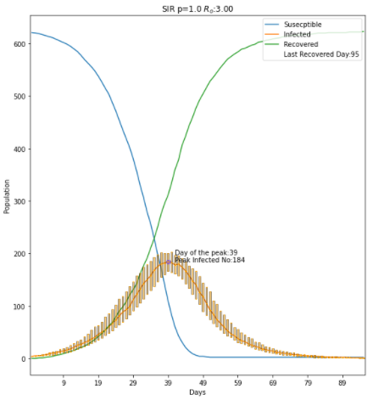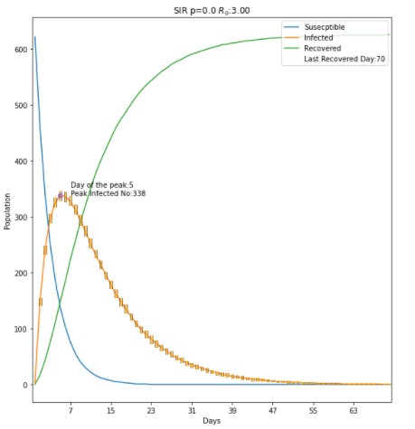

|  |  |  |
| --- | --- | --- |
|  | Total Global Transmission | Total Local Transmission |
| Day of Peak | 5 | 39 |
| Peak Infected | 338 | 184 |
| Last Day of Recovered | 70 | 95 |

From the table one can notice that the peak infected is almost half for the LT than the GT. Thus one can ideally deduce how important it is to have restriction to contain a virus that is highly contagious as similar as covid. Peak Infected also gives us an idea how packed will be the health care bodies of the state. Here in this observation hospital capacity needs to be double than the case of local transmission which is an very high requirement for a governing body. The sudden demand of the hospital capacity will also results in high death rate as we have seen in the various countries with less infra structure. In the case of China the have managed to create a makeshift hospital capacity of huge number of beds. One can also observe that the decision taken with respect to the spread of virus should be quick for the GT. In this simulation it took only 5 days for GT whereas the LT took 39 days to reach the peak infected.

Increasing Beta value for Particular TR

The spread of different disease is vary with many characteristics. Here we would like to investigate how much it affects the spread with increase in transmissibility in a less restricted environment. This can help to determine the important of medical care occupancy that can expected with the beta value of a disease.

Assumption

Beta = (2.1,3.5,6.3)

Gamma=0.7

TR=0.4

The assumption is to know the effect increasing beta value in the dynamics of the disease. TR of 0.4 is chosen to make it more tandem with the realistic conditions of less restriction that is prevailing in countries now. Beta value in the case of corona virus was different at each time. The different variant is said to have transmission rate different. So with each time the number of infected people also increased with high pace. Once could notice in Germany that for each wave the total infected has continued to increase . This can be easily identified given the rise of infected people in the countries. But there is also another fact that is restrictions of the government has also continued to reduce with each wave. This could also be the reasons for continued increase in infected People. From the simulations we could also notice the same.

|  |  |  |  |
| --- | --- | --- | --- |
|  | Beta = 2.5 | Beta= 3.5 | Beta =4.9 |
| Day of Peak | 7 | 5 | 3 |
| Peak Infected | 336 | 407 | 448 |
| Last Day of Recovered | 70 | 67 | 68 |

Looking at the data in the table we can see that there is not much significant difference between the Days of the disease dynamics. Weather it is the day of peak or the day of last Person getting recovered. But the Number of people getting infected is almost 110 different than the other extreme Beta considered.

Change of Dynamics with change in restrictions

This simulations has given high focus on the transmission dynamics based on the nature of transmission. Which can be compared with the restrictions given to a city or state. Here in the case we would like to compare the spread dynamics for a particular beta value. The case of only GT and LT was ignored as it is highly impractical. Change in TR can be considered as increase in the people mobility and giving more chance to spread the virus. In the real world one could also notice the change when the government has slowly reduce the restriction and in the present case the restrictions are almost nil except for the case of medical

|  |  |  |  |  |
| --- | --- | --- | --- | --- |
|  | TR=0.1 | TR=0.4 | TR=0.7 | TR=.0.9 |
| Day of Peak | 6 | 7 | 9 | 11 |
| Peak Infected | 337 | 336 | 320 | 284 |
| Day of last Recovered | 71 | 70 | 72 | 82 |

institutions . These are the cases in the Germany.

Assumptions:

Beta=2.1

Gamma= 0.7

TR=(0.1,0.4,0.7,0.9)

From the above table one can see that the there is no much change for the case of high GT levels. Given the case we could say that the due to less population considered the spreading is very quick and reaches the majority of the population instantaneously . One can also deduce that for an effective curbing of the contagious disease, a restriction of high level is needed to make a significant changes.

Correlation of Beta and Transmission Ratio

Having an insight before hand is the reason why simulations are widely used. Using in this simulation we are trying to understand the dynamics of the disease for different Beta value and its effects on reaching the 50% of the population with increasing restrictions. As we have had earlier closer look in the effects of increasing TR can be seen in this comparison too. But there is a broader comparison in this case. Visualizing the dynamics of the virus with different beta and TR in plot brings in whole different view. For this simulations is run 100 times for each different combinations for 10 values of TR and 5 different values of Beta.

In this one could easily notice that the Beta value of 0.7 is highly offsetted compared to the other plots. That means it took much more days for the beta of very low value but after a threshold the days didn’t make much significant difference. It could also be reasoned that the less number of population is one of the reason for this behavior. Another trend that is to be noticed is the steep observed for all the cases near to the end of TR. This confirm that the observation made in the previous case. That is the restrictions should be made stricter to make a significant decrease in the spread of the virus. The trend of spread is almost similar until the value of 0.7 TR.

Introduction of Vaccination

Another method to curb the spread of the disease is to introduce vaccination. Vaccination is gives immunity to the individual for a long term in order of years. But in case of covid it was noticed that the even the vaccinated people are getting infected with the virus. In this simulation we have incorporated the vaccination to know how it would make difference in spread of the disease. To include it 2 parameters are considered .Number of people getting vaccinated in a day and efficacy of the vaccination. For the government to consider the number of people to get vaccinated in a day has many other parameters that bring effect. Since the corona virus was a neo virus to effect the human population and effective vaccination was not there. Since the presence of the corona virus the scientist were in high pressure to develop a vaccination as quickly as possible . Due to the immediate demand for the virus the usual procedure to develop a virus had to be bypassed by many manufacturers. Thus the effectiveness of the vaccination was a huge question mark. So considering the factors 2 features are modified. The simulation were conducted to get insight on how the difference could be related to get the same peak infected for different TR.

Assumptions

Beta= 2.1

Gamma=0.7

Vaccinations per day= 20

Efficacy=90%

The Iterations were carried out with increasing order of TR and 100 simulations were conducted as mentioned earlier to take the average of each condition. Here we were able to get 284 infections in the case of unvaccinated for TR of 0.9.That is with high level of restrictions. Now if the restriction were to decrease and the introduce vaccination with the above mentioned values the same level of infections of 284 was achieved at 0.2 TR. As mentioned in the previous cases the steady level of the peak infection can be noticed in the case of Unvaccinated situation. But it is much different in the case of the Vaccinated simulation. There is slow decrease with the increase in the TR. Thus it could be concluded that the vaccination plays a important role in the epidemiology.

Under consideration of the peak days there has not been any difference for both the cases. It took almost the similar days to reach the peak. One can notice the spike for the unvaccinated case and not seen in vaccinated. This can be explained by mentioning the people are reaching the recovered stage after getting vaccinated unlike the other. So the constant vaccination made sure that the most population are entered into the Recovered compartment by the constant rate of vaccination even for the case of Total Local Transmission.